EXP. 4

NAME:Thirumala sri.P

REG. NO.:240701569
Create a prototype with familiar and unfamiliar navigation elements. Evaluate ease of use with different user groups using proto.io
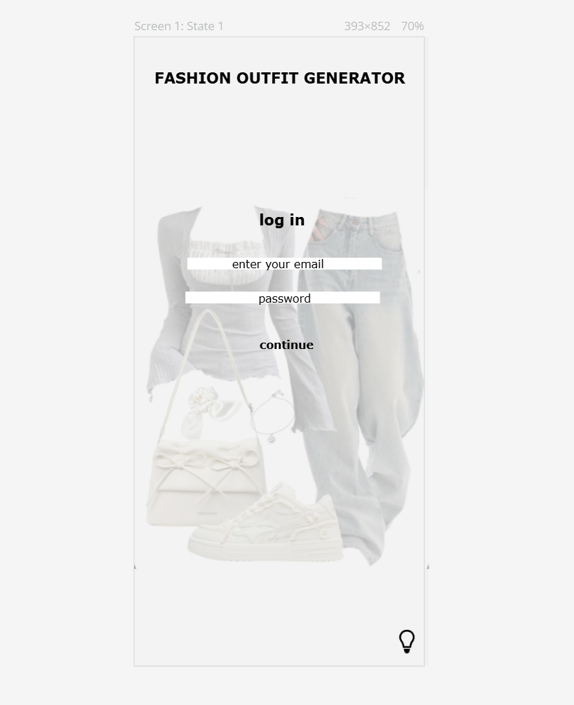
Familiar Elements:
The login page includes standard UI components such as email and password input fields, a continue button, and a clear title at the top. These elements follow common mobile app design patterns, making the interface easy to understand for users.

Unfamiliar Elements:
The use of a fashion outfit image as a background introduces a non-traditional visual hierarchy. Additionally, the icon placed at the bottom right does not represent a typical login action, which may require users to interpret its function. These unfamiliar elements were added to evaluate user adaptability to new navigation cues.
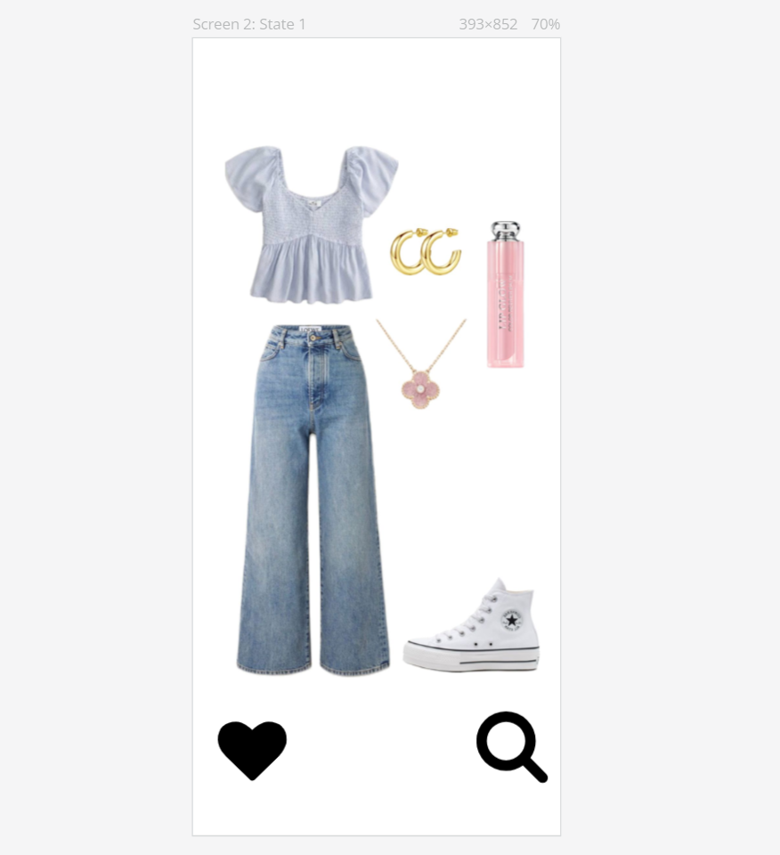
Familiar Navigation Elements

The screen includes several interface elements that users commonly recognise from existing mobile applications. The heart icon placed at the bottom left represents saving or liking an outfit, which is a standard feature in fashion and social media platforms. The search icon positioned at the bottom right follows a universally understood magnifying-glass symbol used to explore or find specific content. Additionally, the large outfit image displayed at the center resembles product cards used in shopping applications, making the layout easy to understand. These familiar components help users quickly recognise basic actions without needing instructions.

Unfamiliar Navigation Elements

Along with familiar tools, this screen introduces an experimental interaction pattern. The outfit card uses a swipe-left and swipe-right gesture, similar to dating applications, instead of traditional buttons for browsing outfits. Swiping right indicates liking or saving the outfit, while swiping left allows the user to skip to the next look. This gesture-based navigation may not be immediately obvious to first-time users because there are no visible arrows or instructions, making it an unfamiliar interaction. The purpose of including this design is to evaluate how users adapt to non-traditional navigation styles and whether gesture-based browsing improves engagement within a fashion application.
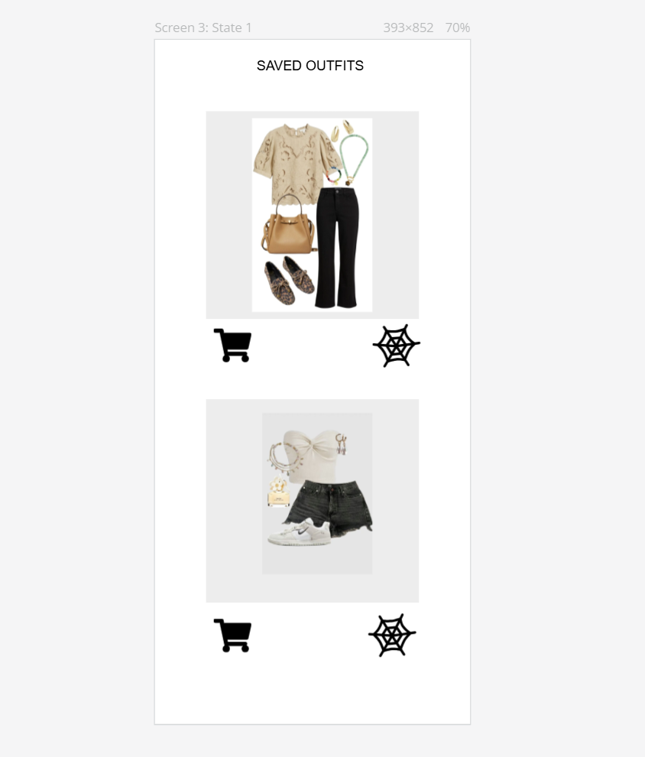
Familiar Navigation Elements

This screen contains several familiar interface components that users commonly recognise from e-commerce and fashion applications. The outfit cards displayed in a vertical layout resemble product listings seen in online shopping platforms, making the interface easy to understand. The shopping cart icon placed below each outfit represents adding items for purchase, which is a standard symbol widely used across digital stores. The clear heading “Saved Outfits” at the top helps users immediately understand the purpose of the page. These familiar elements ensure that users can navigate and interact with the interface without confusion.

Unfamiliar Navigation Elements

In addition to familiar tools, this screen introduces customization features that may feel unfamiliar to first-time users. The web-shaped icon next to each outfit represents a design or customization option rather than a traditional action. Unlike common icons such as edit or settings, this symbol requires users to interpret its meaning, making it an unfamiliar navigation element. The combination of shopping and styling controls within the same screen also introduces a hybrid interaction pattern, where users can both manage saved outfits and personalize their appearance. This experimental design allows the prototype to evaluate how users respond to non-traditional icons and customization workflows.
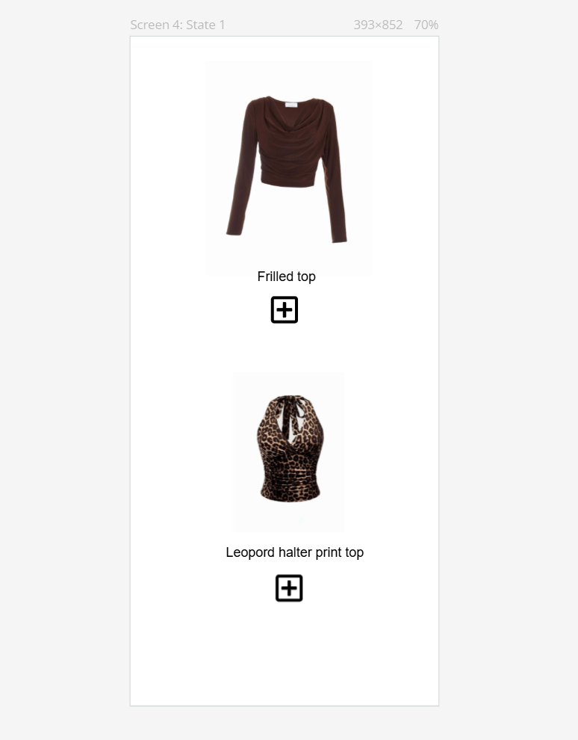
Familiar Navigation Elements

This screen uses several familiar interface components commonly seen in fashion and shopping applications. The layout displays clothing items in a vertical list with clear images and labels such as “Frilled top” and “Leopard halter print top,” which resembles product browsing pages in online stores. The plus (+) icon placed below each item represents adding or selecting an outfit, which is a widely recognised symbol used for adding items to a collection, cart, or wardrobe. The simple product-card design helps users quickly understand how to interact with the available options without needing additional instructions.

Unfamiliar Navigation Elements

Although the plus (+) icon is generally familiar, its use here as a styling or outfit-building action introduces a slightly unfamiliar interaction pattern. Instead of adding items to a shopping cart, the icon functions as a customization or outfit-creation tool, which may require users to interpret its purpose differently. Additionally, the minimal layout without visible navigation bars or category filters creates a simplified but unconventional browsing experience. This design encourages users to focus on individual clothing selections while evaluating how they adapt to a non-traditional fashion customization interface.

Prototype links:

https://pr.to/1DG88Y/
https://pr.to/1DG88Y/
https://pr.to/1DG88Y/
https://pr.to/1DG88Y/

